INSTRUCTIONS
Please read the instructions carefully before doing the questions.
- You can use materials in your computer, notebook and text book.
- You are NOT allowed to use any device to share data with others.
Beside the above conditions, students must follow the following requirements:
1. The work must complete by using Visual Studio 2022++
2. The Framework must be .NET 8.0
3. THIS PART IS VERY IMPORTANT, PLEASE READ IT CAREFULLY AND FOLLOW THE INSTRUCTIONS.
- You are given a database script (.sql file) in Zip file. Execute the script before doing questions.
- You must use the given solution.
- You are not allowed to add any more libraries via NuGet Package Manager into given solution.
- Submission Guideline:
Submit your work for each question separately. For each question, please:
- Publish your project using the command:
dotnet publish -c Release -o ./[QuestionNumber_StudentAccount]
Example:
dotnet publish -c Release -o ./Q1_trungnthe123432
- Submit the root folder of the project into the PEA_Client application.
- If the root folder of the project is too large, you may delete the following subfolders to reduce its size before submitting: /bin, /obj
Just one of above requirements is violated, your work will be considered as invalid.

QUESTION 1
You are provided with a console application Port3000Server in given materials, acting as a TCP server, listening for connections at 127.0.0.1:3000. The server stores information about readers, books, and the relationships between readers and books (borrow records). The server processes client requests as follows:
- The client sends an integer (Reader ID) to the server.
- The server responds with a JSON string containing a list of books that the reader with the given ID has borrowed, including: Book ID, Title, Author, Borrow Date, Return Date, and Status.
- If the Reader ID does not exist in the readers list, the server returns a special JSON response indicating "Reader not found".
- If the Reader ID exists but has no borrow records, the server returns a JSON containing an empty list.
Your task is to develop a .NET 8 console application that acts as a client, connects to the server, and implements the functionality described below.
The server manages the following data structures:
Readers Table:
- ReaderID (int) - Primary Key
- FullName (string)
- Email (string)
- PhoneNumber (string)
- RegistrationDate (DateTime)

Books Table:
- BookID (string) - Primary Key
- Title (string)
- Author (string)
- ISBN (string)
- PublishYear (int)
- Category (string)

BorrowRecords Table:
- RecordID (int) - Primary Key
- ReaderID (int) - Foreign Key
- BookID (string) - Foreign Key
- BorrowDate (DateTime)
- ReturnDate (DateTime?) - Nullable
- Status (string) - "Borrowed", "Returned", "Overdue"
Note: The server will be provided and running on port 3000. You only need to focus on developing the client application.
The client application must:

1. Wait for User Input:
- Continuously prompt the user to enter an integer (Reader ID) via the console.
- If the user presses Enter (empty input), the program terminates.

2. Validate Input:
- Check if the user input is a valid integer greater than 0.
- If the input is not a valid integer or not greater than 0, display an error message and prompt the user to try again.
Examples of invalid input:
Enter Reader ID (or press Enter to exit): abc
Invalid input! Please enter a valid Reader ID (positive integer).

Enter Reader ID (or press Enter to exit): -5
Invalid input! Please enter a valid Reader ID (positive integer).

Enter Reader ID (or press Enter to exit): 0
Invalid input! Please enter a valid Reader ID (positive integer).

3. Connect to the Server:
- Establish a TCP connection to the server at 127.0.0.1:3000.
- Send the integer (Reader ID) entered by the user to the server.
- If the server is not running or the connection fails, display an error message (e.g., "Library server is not running. Please try again later.") and return to waiting for new user input.
Example connection failure:
Enter Reader ID (or press Enter to exit): 101
Library server is not running. Please try again later.

4. Process Server Response:
- Receive the JSON string from the server and deserialize it.
- The server can return three types of responses:
1. Reader not found: Display "Reader with ID {ID} does not exist."
2. Reader exists with borrow records: Display each book's information in a clear format
3. Reader exists with no borrow records: Display "No borrow records found for Reader ID {ID}."
Example - Reader does not exist:
Enter Reader ID (or press Enter to exit): 999
Reader with ID 999 does not exist.
Example - Reader exists but no borrow records:
Enter Reader ID (or press Enter to exit): 103
No borrow records found for Reader ID 103.
Example - Reader exists with borrow records:
Enter Reader ID (or press Enter to exit): 101
=== Borrow History for Reader ID: 101
Book ID: B1001
Title: The Great Gatsby
Author: F. Scott Fitzgerald
Borrow Date: 2024-01-15
Return Date: 2024-02-15
Status: Returned
---
Book ID: B1002
Title: To Kill a Mockingbird
Author: Harper Lee
Borrow Date: 2024-02-20
Return Date: Not returned yet
Status: Borrowed
---
Book ID: B1003
Title: 1984
Author: George Orwell
Borrow Date: 2024-01-10
Return Date: 2024-02-25
Status: Overdue

- After processing the response, return to waiting for new user input unless the user has entered an empty string.
Example program termination:
Enter Reader ID (or press Enter to exit):
Goodbye! Library client is shutting down.

QUESTION 2
In this question, you are asked to write an MVC/Razor Pages application, using a database that has the following schema:
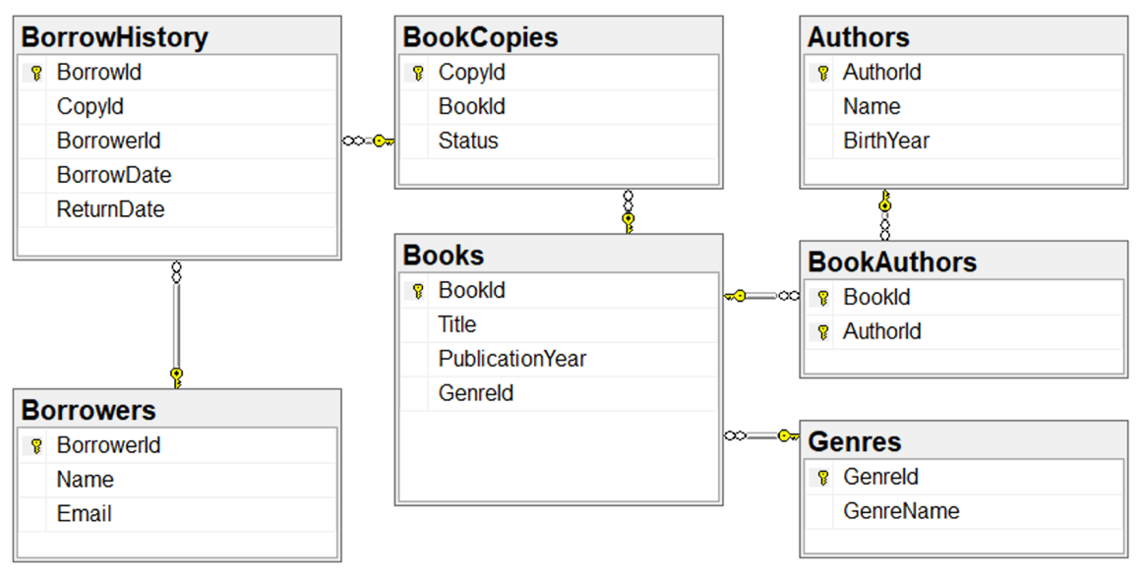

1. Important Notes:
- It is required to assign the URL to access the web page as given. Wrong URL will result in the examiner cannot access your developed features. You will receive ZERO for any WRONG URL.
- Zero marks will be awarded if the database connection string is not stored in the file appsettings.json.
- All input and output elements in the HTML source must have an 'id' attribute to ensure accessibility and traceability. Students can refer to the list.html and detail.html files in given materials, which provides code snippets for the assignment.

2. Requirements

2.1. Book List Page (see Figure 1)

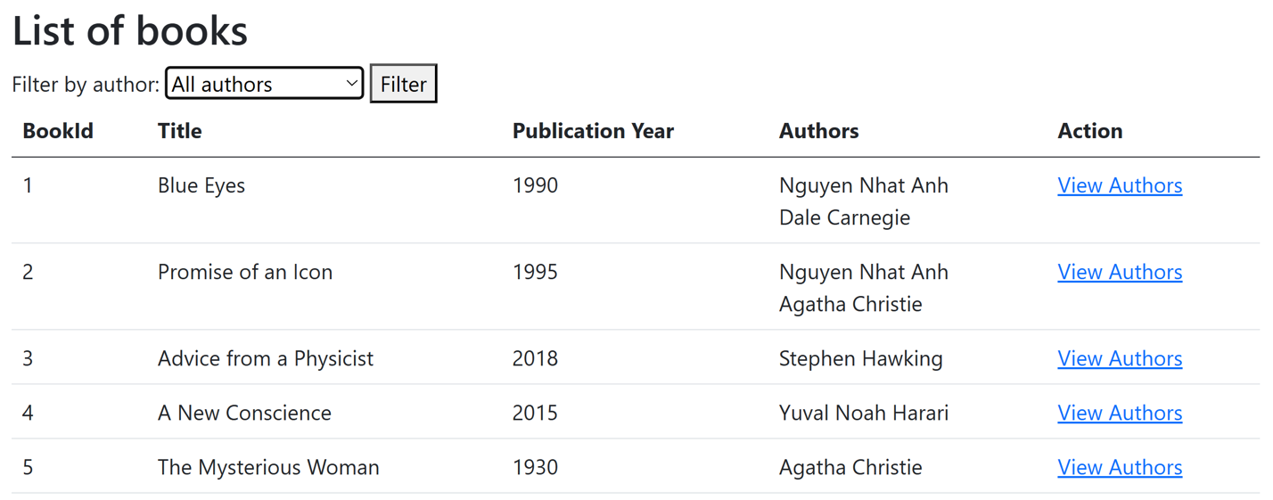
Figure 1. The Book List page.
URL: /Book
- Display all books from the Books table in a tabular format with the following columns:
- BookId.
- The book's title (e.g., "Programming in C#").
- PublicationYear.
- Authors: The list of the book's authors (retrieved from the Authors table via BookAuthors). Each author's name is placed on a separate line.
- Each row in the table should have a "View Details" link redirecting to the detail page with the URL /Book/{BookId}.
- Include a dropdown list that displays all authors from the database (from the Authors table). Add into dropdownlist the item "All authors".
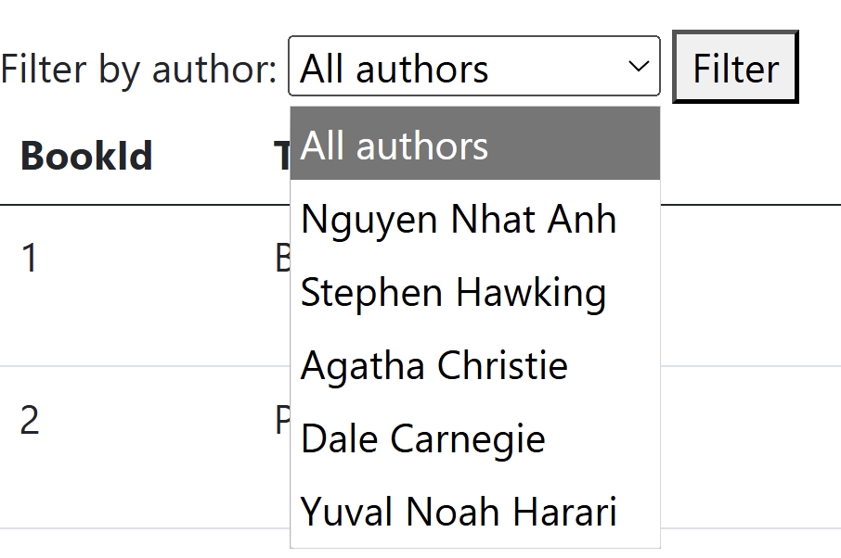
Figure 2. List of options in Author DropDownList.
ID Requirements:
- Each <td> tag in the table that lists books will have an id in the form td_{columnName}_{bookId} (where bookId is the id in database of the book and columnName written in camelCase format): td_bookId_1, td_title_1, td_publicationYear_1, td_authors_1, td_action_1
- Each author's name in column Authors, must be placed in an <div> tag with id div_{bookId}_{authorId} (where bookId and authorId are the id in database of book and author). Example: div_1_1
- Each "View Authors" link must be placed in an <a> tag with id a_{bookId}. Example a_1
- The Dropdownlist using <select> tag that has id sl_authors
- The option "All authors" is set by default, using <option> tag with id op_0
- Each option tag in Dropdownlist has an id in the form op_{authorId} (where authorId is the id in database of author). Example: op_1, op_2

2.2. Filter books by author (see Figure 1)
- When a user selects an author from the dropdown and clicks the "Filter" button, the book list should only show books associated with the selected author. Note that, if the user selects "All authors" list all the books.
- The [Filter] button using <input> tag that has id bt_filter

2.3. Book Authors Detail Page (see Figure 2)

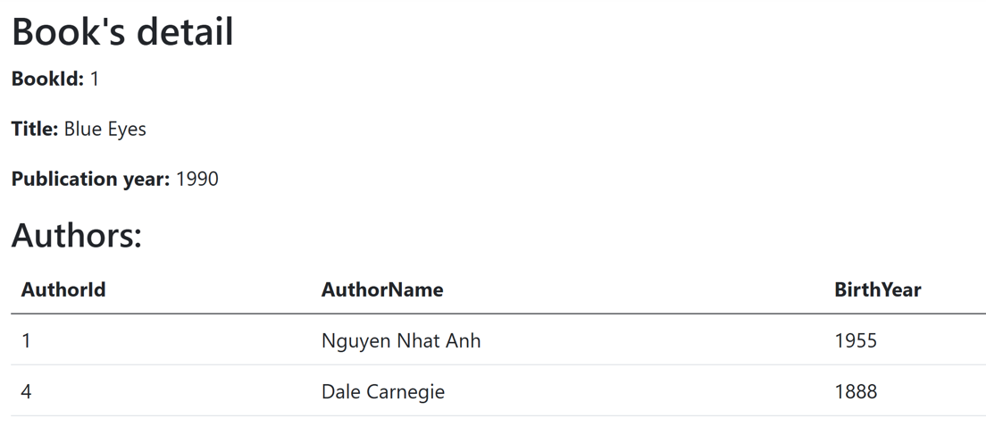
Figure 3. The Book Authors Detail page.
- URL: /Book/{BookId} (e.g., /Book/1)
- Display basic information of the book:
BookId: The book's ID.
Title: The book's title.
PublicationYear: The publication year.
- Display a list of all authors associated with the book in a table with the following columns:
AuthorId: The author's ID
Name: The author's name
BirthYear: The author's birth year
ID Requirement:
- Each piece of basic information in the book (BookId, Title, Publication Year) is placed within a <span> tag, with the IDs being as folows span_bookId, span_title, span_publicationYear.
- Each <td> tag in the table that lists authors will have an id in the form td_{columnName}_{authorId} (where authorId is the id in database of the author and columnName written in camelCase format). Example: td_authorId_1, td_authorName_1, td_birthYear_1

3. Summary of HTML Elements ID
The HTML id requirements are summarized in the table below:
Page | Element | Element Tag | Id
/Book/ | Each cell in the table that lists books | <td> | td_{columnName}_{bookId}
 | Each author in list of authors of one book (in table) | <div> | div_{bookId}_{authorId}
 | Each ViewAuthors link | <a> | a_{bookId}
 | DropdownList Authors (Filter) | <select> | sl_authors
 | Option "All Authors" (Filter) | <option> | op_0
 | Each author option in DropdownList | <option> | op_{authorId}
 | Button Filter | <input> | bt_filter
/Book/{BookId} | Field BookId | <span> | span_{bookId}
 | Field Title of book | <span> | span_{title}
 | Field PublicationYear | <span> | span_{publicationYear}
 | Each cell in the table that lists authors | <td> | td_{columnName}_{authorId}
See list.html and detail.html in the Given Materials
Note: Ensure all ID requirements are strictly followed so that the examiner can automatically verify your work.

4. Summary of Required URLs
Function | URL
List and filter books | /Book
Details of the book with id {BookId} | /Book/{BookId}

